Theory of Automata (CS3005)
Date: April 8th 2025
Course Instructor(s)
Dr. Nasir Uddin, Syed Faisal Ali, Ms. Shaharbano, Ms. Bakhtawar, Ms. Ms. Abeeha Sattar
Sessional-II Exam
Total Time (Hrs): | 1
Total Marks: | 15
Total Questions: | 4

__________ __________ _____________________
Roll No Section Student Signature

Do not write below this line
Attempt all the questions.
- Do not waste pages by adding extra sheets.
- Draw proper readable diagrams to get marks.
- Solve the paper according to the question order.

CLO #4: DFA minimization

Question 1: DFA Minimization using any algorithm. [Marks: 04]
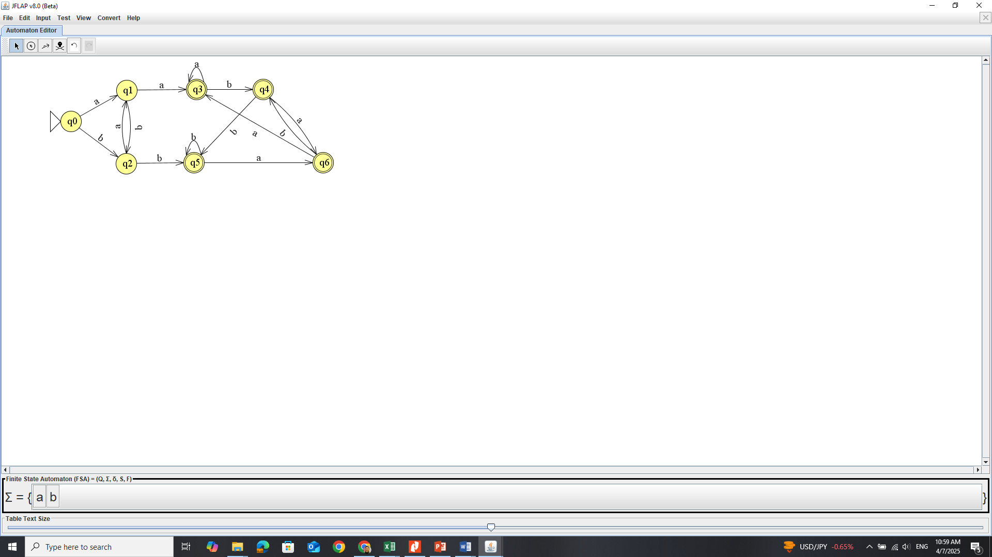

CLO # 3: Kleene’s Properties

Question 2. Kleene’s Theorem [Marks: 04]
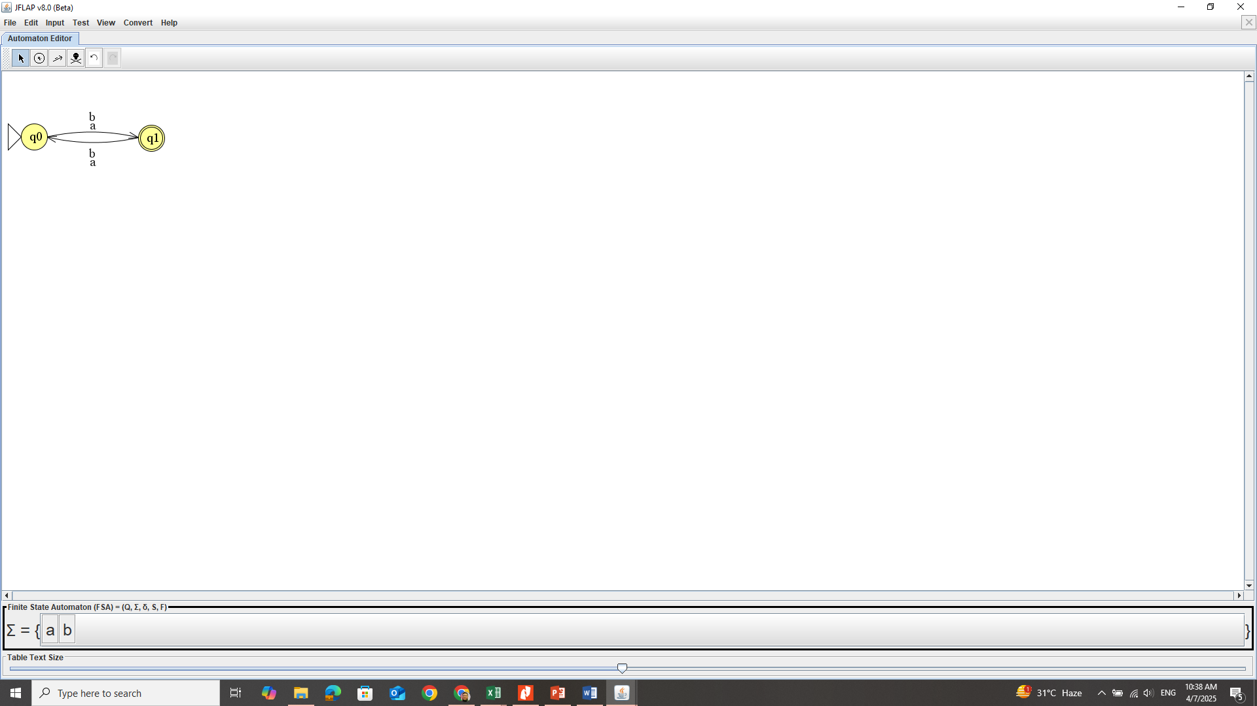
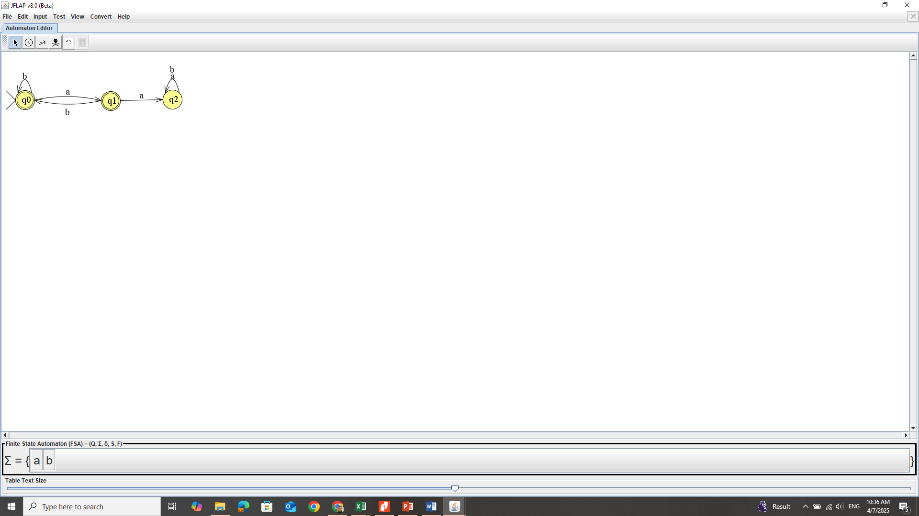
FA1: FA2:

- Concatenate FA1 with FA2 resulting FA1.FA2.

Consider the following two DFAs (FA1 and FA2):
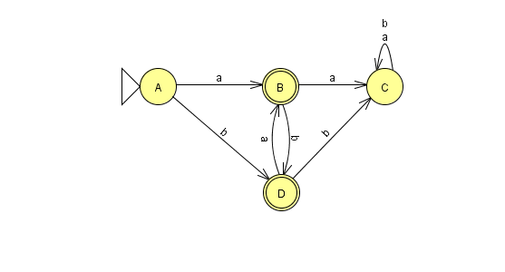
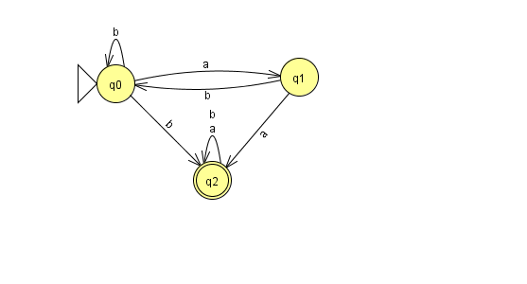
FA1: FA2:

- What will be the resultant DFA (Union) and DFA (intersection) of the FA1 and FA2? Write two strings of each FA, and prove that the result of Union and Intersection support’s your string answer.
Show proper steps for both parts including any diagrams or tables that you are using to reach the final DFA.

CLO # 2: Pumping Lemma
Question 3: Use Pumping Lemma to prove the following language is non regular. [Marks: 02]
- $L =\left\{ab^{n}ac^{n+2}\right|n∈N$}
- Use pumping lemma to show that whether L$=a^{i} b 3^{i} i≥100 and i≤500$ is non-regular or regular . show your steps against each of the pumping Lemma.
CLO # 4: Finite Automata with Outputs

Question 4: Finite Automata with outputs.
- Given the following Mealy Machine, create its equivalent Moore Machine. [Marks: 02]
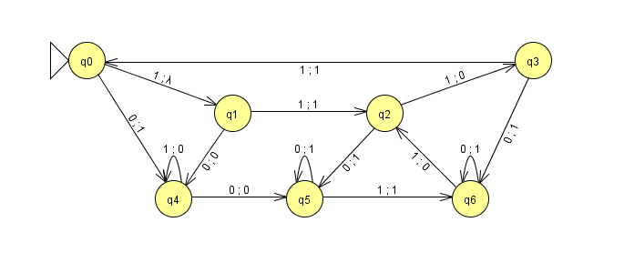
- Create a Moore machine which provides the remainder as output when a number is divided by 5. Provided Σ = {0,1,2,3,4,5,6,7,8,9} [Marks: 03]
Solution:
Question 1 Time 10 Mins DFA Minimization
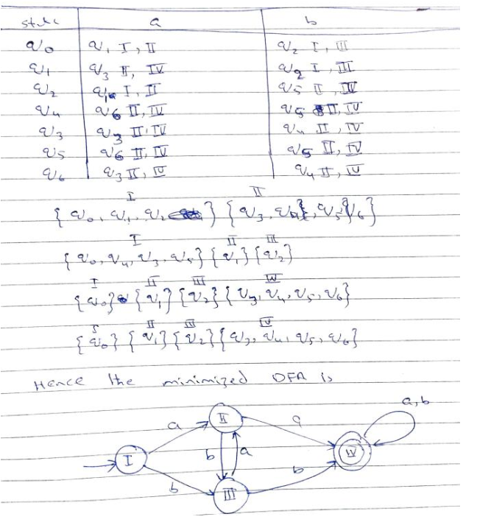

Question 2: Time 10 Mins Kleene’s Theorem
Concat
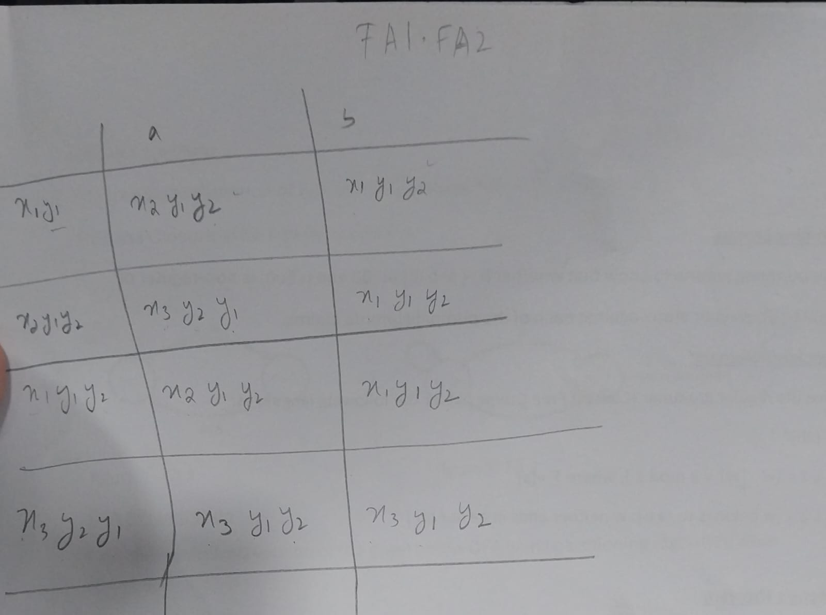

Union/Intersection (after converting FA1 to DFA)
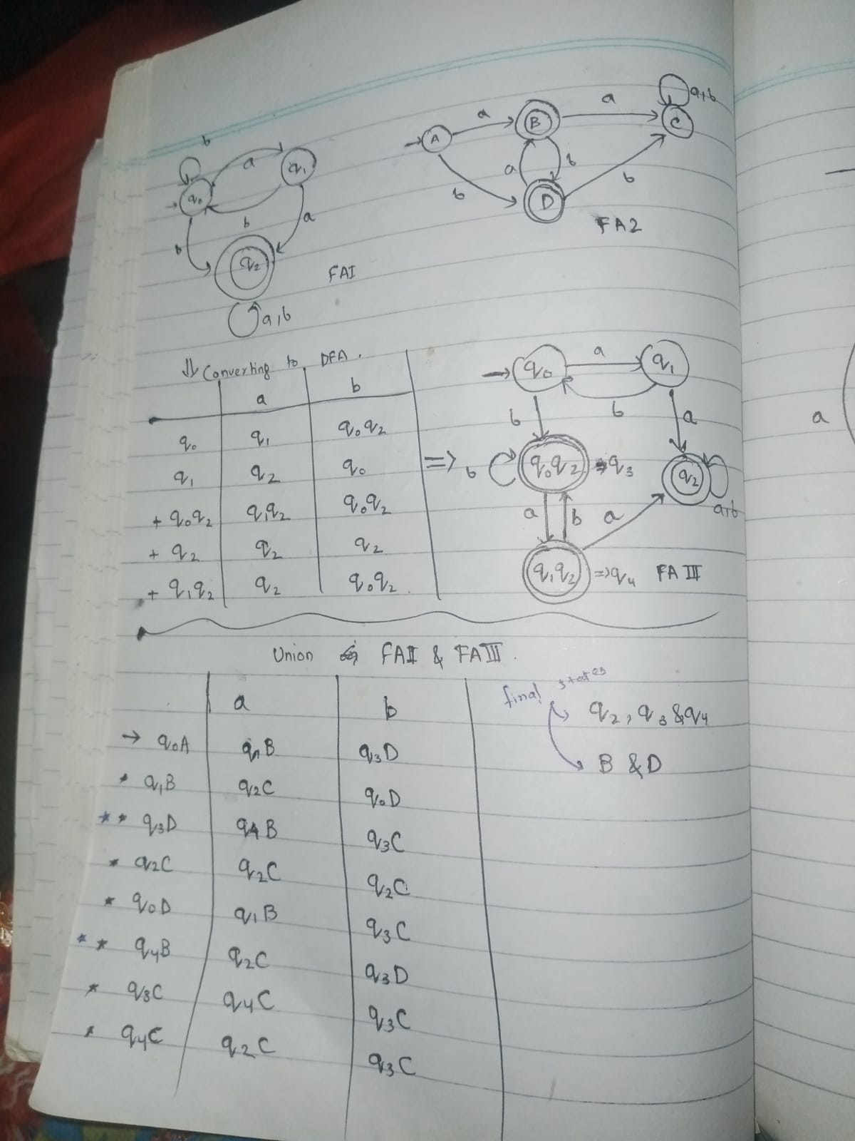

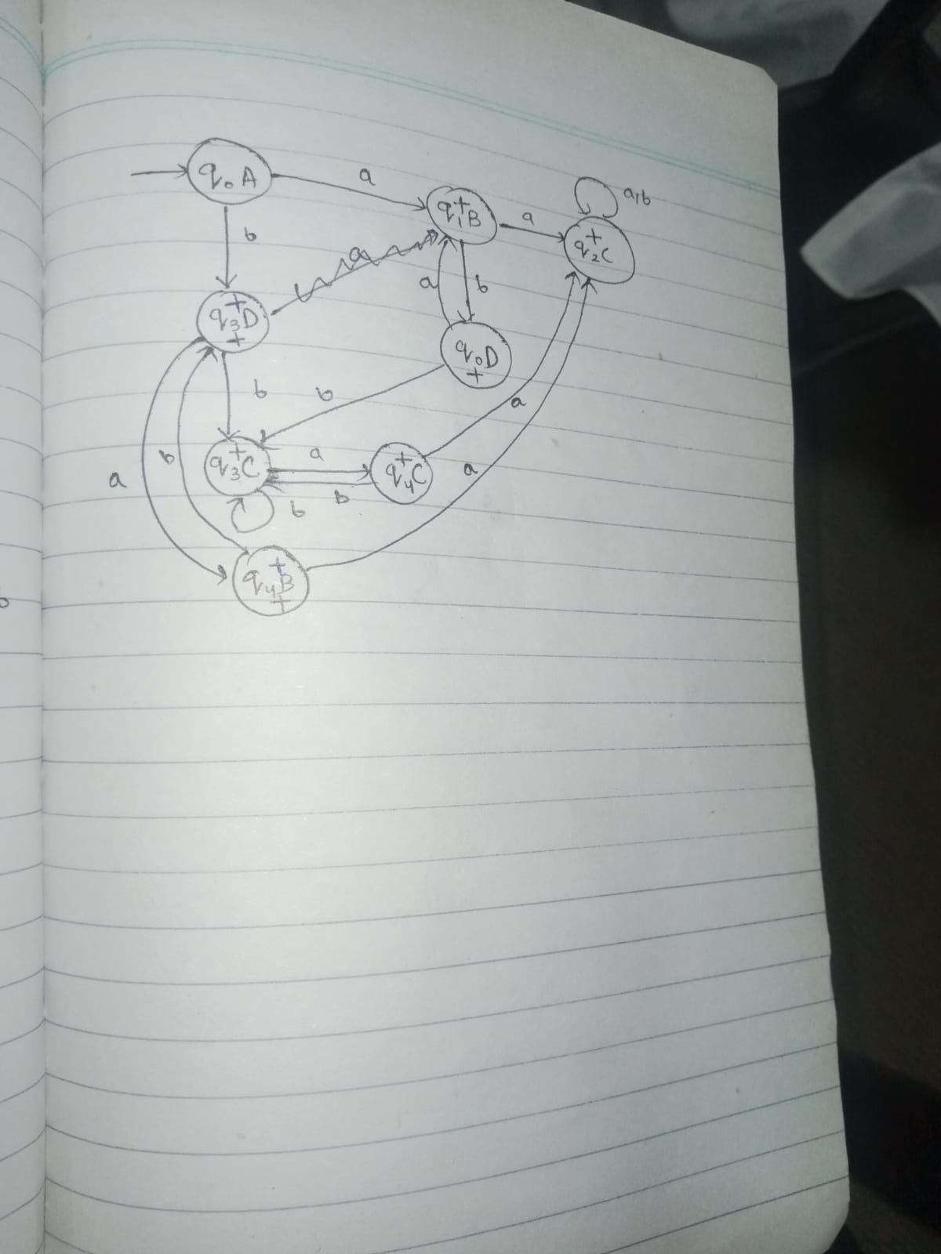

Union/Intersection (FA1 not converted to DFA)
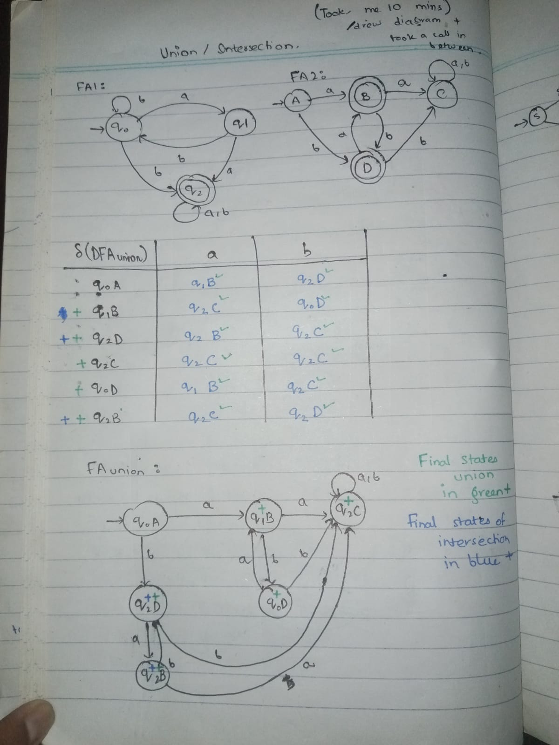

Solution Question 3: Pumping Lemma Time (5 Mins)
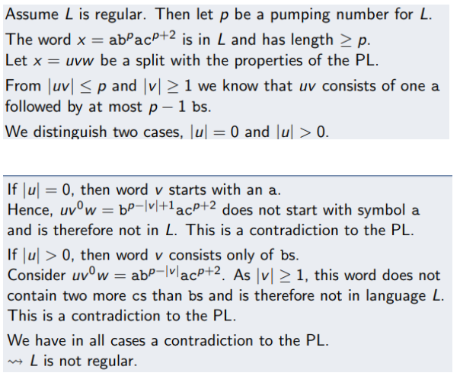

Question 4: i (Time 10 Mins)
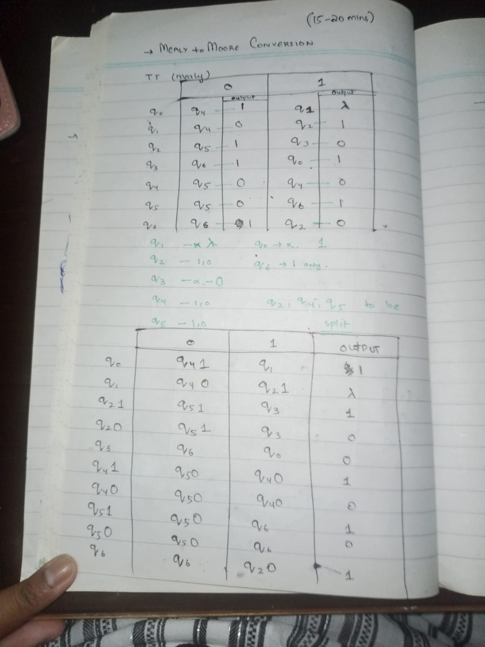
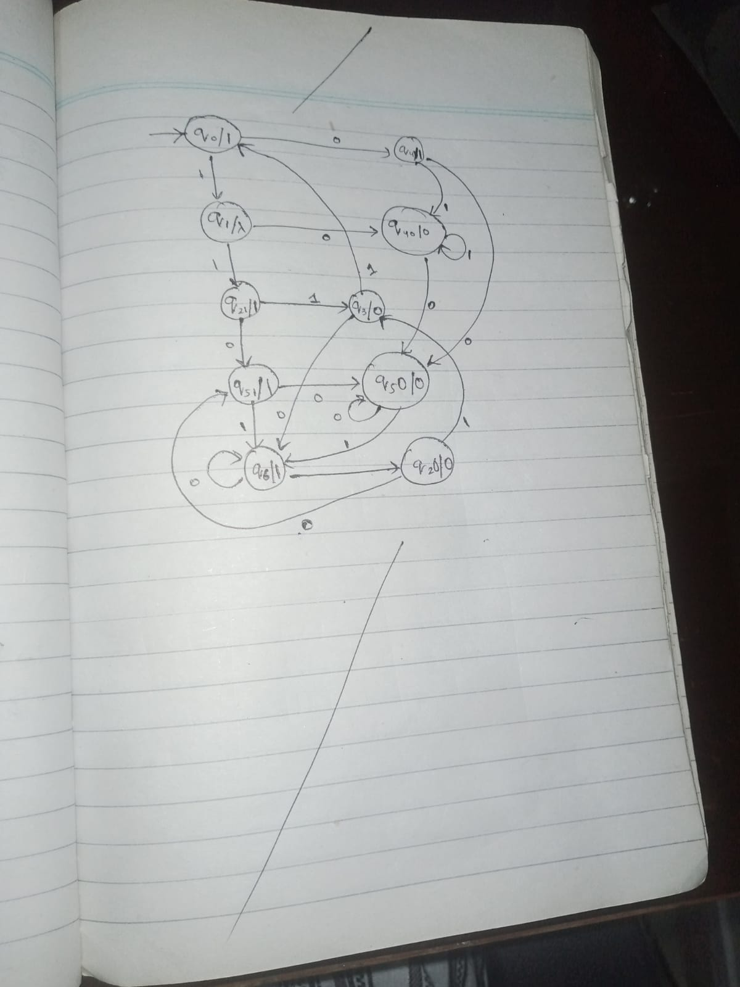

Question 4 ii. Time (15 mins)
